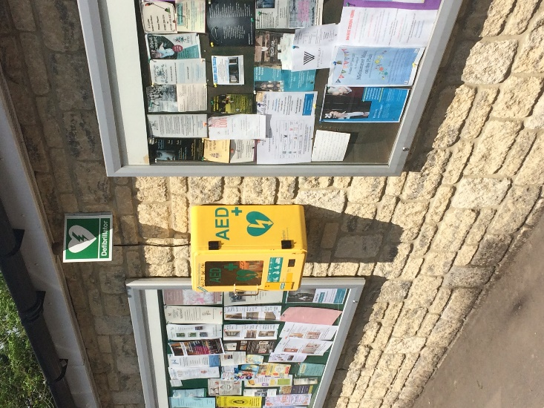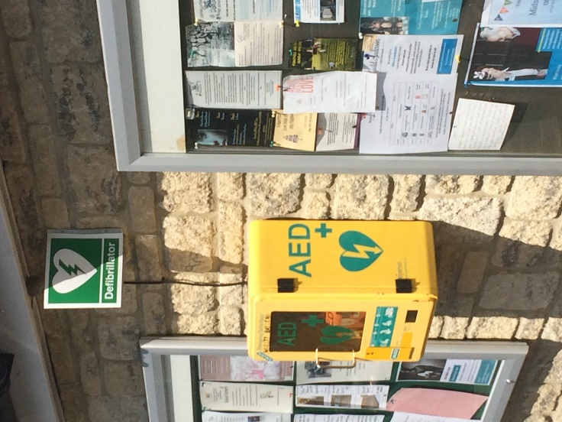
Defibrillator at Budgens Defibrillator at the Village Hall

The parish is now provided with TWO defibrillators:
Both AEDs are in yellow cabinets mounted externally on the side wall of the Village Hall facing the car park and one the end elevation of Budgens shop facing the A36. Access to the AED is by unclipping the two catches on the Left-hand side of the box and pulling the door open. If an alarm goes off, ignore it (it only signals that the door is open). Close the door and the alarm becomes silent. Take the AED to where it is needed and follow the voice instructions which begin as soon as the AED lid is opened.
Please return the AED after use and follow the instructions on the inside of the yellow cabinet. This will ensure that the AED custodians inspect the device and make it ready for any subsequent use.
IF YOU COME ACROSS A PERSON COLLAPSED, DIAL 999, ASK FOR THE AMBULANCE SERVICE, DESCRIBE THE SYMPTOMS AND YOUR LOCATION, AND THEY WILL TELL YOU WHERE THE NEAREST DEFIBRILLATOR IS. FETCH THE PACK (OR GET SOMEONE ELSE TO) FROM THE UNLOCKED CABINET AND RETURN TO YOUR PATIENT, OPEN THE PACK AND FOLLOW THE INSTRUCTIONS. YOU DO NOT NEED TRAINING - THE DEVICE IS AUTOMATIC AND WILL TALK TO YOU.
The service is provided by the Parish Council in partnership with SW Ambulance Service and has been part-funded by Codford Community.

